**Practica Nro. 3**

**Apellidos y Nombres: VARGAS PAUCARA BORIS**

Realice la codificación de los siguientes problemas:

1. Cree un proyecto Laravel, cuyos elementos requerimientos son:

* Crear la Base de datos en MySql con las tablas necesarias a libre elección (libre modelación).
* El proyecto debe contener una interface de login para poder entrar a un dashboard.
* El proyecto deberá tener un CRUD de una de sus tablas.
* Debe agregar una vista que contenga el menú de opciones (que serán enlaces al CRUD) del proyecto.

La solución debe ser entregada en un archivo PDF, que debe contener el código fuente y luego capturas de pantalla de los resultados.

SOLUCIÓN:

**CONEXIÓN BASE DE DATOS**

DB_CONNECTION=mysql

DB_HOST=127.0.0.1

DB_PORT=3306

DB_DATABASE=cursounivalle

DB_USERNAME=root

DB_PASSWORD=

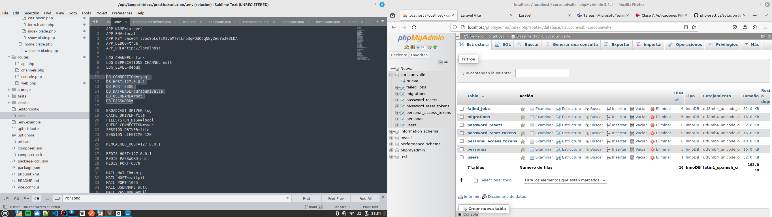**MODELOS USER Y PERSONAS**

**User.php**

<?php

namespace App\Models;

// use Illuminate\Contracts\Auth\MustVerifyEmail;

use Illuminate\Database\Eloquent\Factories\HasFactory;

use Illuminate\Foundation\Auth\User as Authenticatable;

use Illuminate\Notifications\Notifiable;

use Laravel\Sanctum\HasApiTokens;

class User extends Authenticatable

{

use HasApiTokens, HasFactory, Notifiable;

/**

* The attributes that are mass assignable.

*

* @var array<int, string>

*/

protected $fillable = [

'name',

'email',

'password',

];

/**

* The attributes that should be hidden for serialization.

*

* @var array<int, string>

*/

protected $hidden = [

'password',

'remember_token',

];

/**

* The attributes that should be cast.

*

* @var array<string, string>

*/

protected $casts = [

'email_verified_at' => 'datetime',

'password' => 'hashed',

];

}

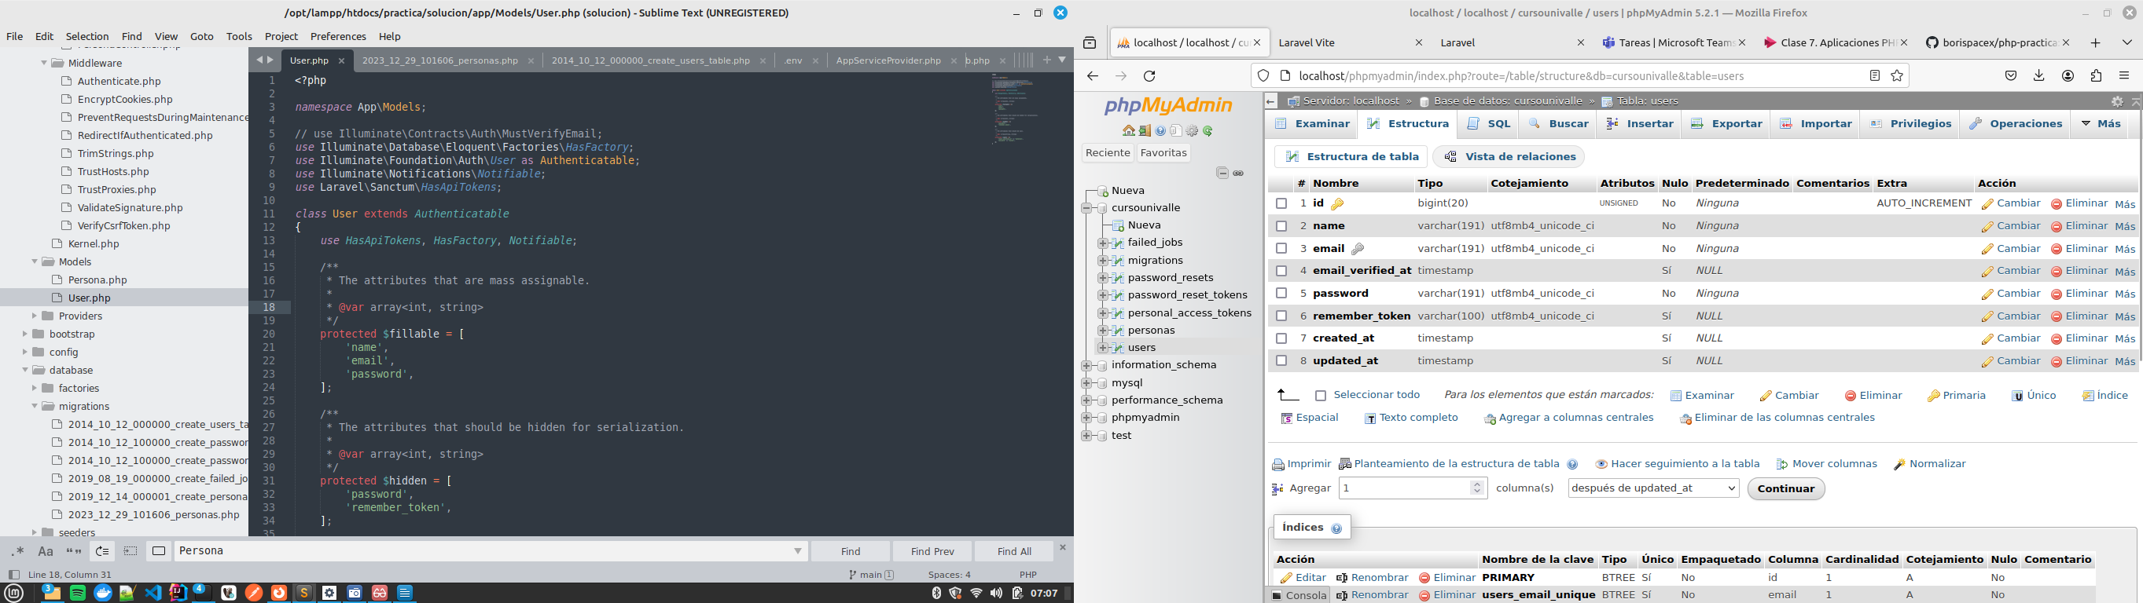

**Persona.php**

<?php

namespace App\Models;

use Illuminate\Database\Eloquent\Model;

/**

* Class Persona

*

* @property $id

* @property $paterno

* @property $materno

* @property $nombre

* @property $direccion

*

* @package App

* @mixin \Illuminate\Database\Eloquent\Builder

*/

class Persona extends Model

{

static $rules = [

'paterno' => 'required',

'materno' => 'required',

'nombre' => 'required',

'direccion' => 'required',

];

protected $perPage = 20;

/**

* Attributes that should be mass-assignable.

*

* @var array

*/

protected $fillable = ['paterno','materno','nombre','direccion'];

}

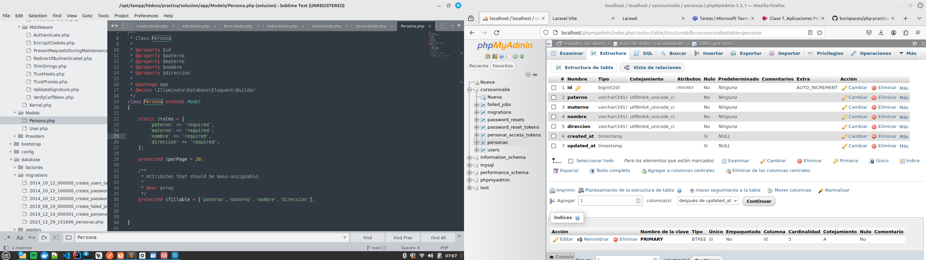

**CONTROLLERS AUTH USER Y PERSONA**

**LoginController.php**

<?php

namespace App\Http\Controllers\Auth;

use App\Http\Controllers\Controller;

use App\Providers\RouteServiceProvider;

use Illuminate\Foundation\Auth\AuthenticatesUsers;

class LoginController extends Controller

{

/*

|--------------------------------------------------------------------------

| Login Controller

|--------------------------------------------------------------------------

|

| This controller handles authenticating users for the application and

| redirecting them to your home screen. The controller uses a trait

| to conveniently provide its functionality to your applications.

|

*/

use AuthenticatesUsers;

/**

* Where to redirect users after login.

*

* @var string

*/

protected $redirectTo = RouteServiceProvider::HOME;

/**

* Create a new controller instance.

*

* @return void

*/

public function __construct()

{

$this->middleware('guest')->except('logout');

}

}

**PersonaCotroller.php**

<?php

namespace App\Http\Controllers;

use App\Models\Persona;

use Illuminate\Http\Request;

/**

* Class PersonaController

* @package App\Http\Controllers

*/

class PersonaController extends Controller

{

/**

* Display a listing of the resource.

*

* @return \Illuminate\Http\Response

*/

public function index()

{

$personas = Persona::paginate();

return view('persona.index', compact('personas'))

->with('i', (request()->input('page', 1) - 1) * $personas->perPage());

}

/**

* Show the form for creating a new resource.

*

* @return \Illuminate\Http\Response

*/

public function create()

{

$persona = new Persona();

return view('persona.create', compact('persona'));

}

/**

* Store a newly created resource in storage.

*

* @param \Illuminate\Http\Request $request

* @return \Illuminate\Http\Response

*/

public function store(Request $request)

{

request()->validate(Persona::$rules);

$persona = Persona::create($request->all());

return redirect()->route('personas.index')

->with('success', 'Persona Agregada!!');

}

/**

* Display the specified resource.

*

* @param int $id

* @return \Illuminate\Http\Response

*/

public function show($id)

{

$persona = Persona::find($id);

return view('persona.show', compact('persona'));

}

/**

* Show the form for editing the specified resource.

*

* @param int $id

* @return \Illuminate\Http\Response

*/

public function edit($id)

{

$persona = Persona::find($id);

return view('persona.edit', compact('persona'));

}

/**

* Update the specified resource in storage.

*

* @param \Illuminate\Http\Request $request

* @param Persona $persona

* @return \Illuminate\Http\Response

*/

public function update(Request $request, Persona $persona)

{

request()->validate(Persona::$rules);

$persona->update($request->all());

return redirect()->route('personas.index')

->with('success', 'Persona Actualizada!!');

}

/**

* @param int $id

* @return \Illuminate\Http\RedirectResponse

* @throws \Exception

*/

public function destroy($id)

{

$persona = Persona::find($id)->delete();

return redirect()->route('personas.index')

->with('success', 'Persona Eliminada');

}

}

**MIDDLEWARE**

**Authenticate.php**

<?php

namespace App\Http\Middleware;

use Illuminate\Auth\Middleware\Authenticate as Middleware;

use Illuminate\Http\Request;

class Authenticate extends Middleware

{

/**

* Get the path the user should be redirected to when they are not authenticated.

*/

protected function redirectTo(Request $request): ?string

{

return $request->expectsJson() ? null : route('login');

}

}

**VIEWS**

**layouts/app.blade.php**

<!doctype html>

<html lang="{{ str_replace('_', '-', app()->getLocale()) }}">

<head>

<meta charset="utf-8">

<meta name="viewport" content="width=device-width, initial-scale=1">

<!-- CSRF Token -->

<meta name="csrf-token" content="{{ csrf_token() }}">

<title>{{ config('app.name', 'Laravel') }}</title>

<!-- Fonts -->

<link rel="dns-prefetch" href="//fonts.bunny.net">

<link href="https://fonts.bunny.net/css?family=Nunito" rel="stylesheet">

<!-- Scripts -->

@vite(['resources/sass/app.scss', 'resources/js/app.js'])

</head>

<body>

<div id="app">

<nav class="navbar navbar-expand-md navbar-light bg-white shadow-sm">

<div class="container">

<a class="navbar-brand" href="{{ url('/') }}">

{{ config('app.name', 'Laravel') }}

</a>

<button class="navbar-toggler" type="button" data-bs-toggle="collapse" data-bs-target="#navbarSupportedContent" aria-controls="navbarSupportedContent" aria-expanded="false" aria-label="{{ __('Toggle navigation') }}">

<span class="navbar-toggler-icon"></span>

</button>

<div class="collapse navbar-collapse" id="navbarSupportedContent">

<!-- Left Side Of Navbar -->

@auth

<ul class="navbar-nav me-auto">

<li>

<a class="nav-link" href="{{ route('personas.index') }}">{{ __('Personas') }}</a>

</li>

</ul>

@endauth

<!-- Right Side Of Navbar -->

<ul class="navbar-nav ms-auto">

<!-- Authentication Links -->

@guest

@if (Route::has('login'))

<li class="nav-item">

<a class="nav-link" href="{{ route('login') }}">{{ __('Login') }}</a>

</li>

@endif

@if (Route::has('register'))

<li class="nav-item">

<a class="nav-link" href="{{ route('register') }}">{{ __('Register') }}</a>

</li>

@endif

@else

<li class="nav-item dropdown">

<a id="navbarDropdown" class="nav-link dropdown-toggle" href="#" role="button" data-bs-toggle="dropdown" aria-haspopup="true" aria-expanded="false" v-pre>

{{ Auth::user()->name }}

</a>

<div class="dropdown-menu dropdown-menu-end" aria-labelledby="navbarDropdown">

<a class="dropdown-item" href="{{ route('logout') }}"

onclick="event.preventDefault();

document.getElementById('logout-form').submit();">

{{ __('Logout') }}

</a>

<form id="logout-form" action="{{ route('logout') }}" method="POST" class="d-none">

@csrf

</form>

</div>

</li>

@endguest

</ul>

</div>

</div>

</nav>

<main class="py-4">

@yield('content')

</main>

</div>

</body>

</html>

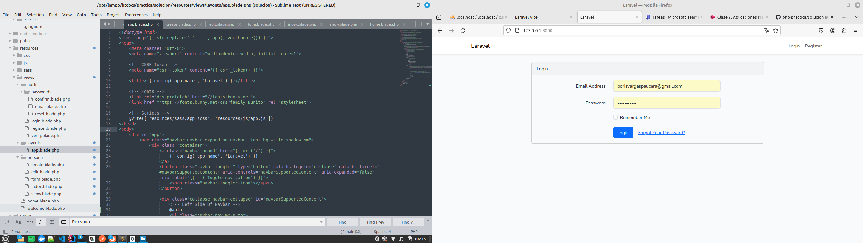

**home.blade.php**

<!doctype html>

<html lang="{{ str_replace('_', '-', app()->getLocale()) }}">

<head>

<meta charset="utf-8">

<meta name="viewport" content="width=device-width, initial-scale=1">

<!-- CSRF Token -->

<meta name="csrf-token" content="{{ csrf_token() }}">

<title>{{ config('app.name', 'Laravel') }}</title>

<!-- Fonts -->

<link rel="dns-prefetch" href="//fonts.bunny.net">

<link href="https://fonts.bunny.net/css?family=Nunito" rel="stylesheet">

<!-- Scripts -->

@vite(['resources/sass/app.scss', 'resources/js/app.js'])

</head>

<body>

<div id="app">

<nav class="navbar navbar-expand-md navbar-light bg-white shadow-sm">

<div class="container">

<a class="navbar-brand" href="{{ url('/') }}">

{{ config('app.name', 'Laravel') }}

</a>

<button class="navbar-toggler" type="button" data-bs-toggle="collapse" data-bs-target="#navbarSupportedContent" aria-controls="navbarSupportedContent" aria-expanded="false" aria-label="{{ __('Toggle navigation') }}">

<span class="navbar-toggler-icon"></span>

</button>

<div class="collapse navbar-collapse" id="navbarSupportedContent">

<!-- Left Side Of Navbar -->

@auth

<ul class="navbar-nav me-auto">

<li>

<a class="nav-link" href="{{ route('personas.index') }}">{{ __('Personas') }}</a>

</li>

</ul>

@endauth

<!-- Right Side Of Navbar -->

<ul class="navbar-nav ms-auto">

<!-- Authentication Links -->

@guest

@if (Route::has('login'))

<li class="nav-item">

<a class="nav-link" href="{{ route('login') }}">{{ __('Login') }}</a>

</li>

@endif

@if (Route::has('register'))

<li class="nav-item">

<a class="nav-link" href="{{ route('register') }}">{{ __('Register') }}</a>

</li>

@endif

@else

<li class="nav-item dropdown">

<a id="navbarDropdown" class="nav-link dropdown-toggle" href="#" role="button" data-bs-toggle="dropdown" aria-haspopup="true" aria-expanded="false" v-pre>

{{ Auth::user()->name }}

</a>

<div class="dropdown-menu dropdown-menu-end" aria-labelledby="navbarDropdown">

<a class="dropdown-item" href="{{ route('logout') }}"

onclick="event.preventDefault();

document.getElementById('logout-form').submit();">

{{ __('Logout') }}

</a>

<form id="logout-form" action="{{ route('logout') }}" method="POST" class="d-none">

@csrf

</form>

</div>

</li>

@endguest

</ul>

</div>

</div>

</nav>

<main class="py-4">

@yield('content')

</main>

</div>

</body>

</html>

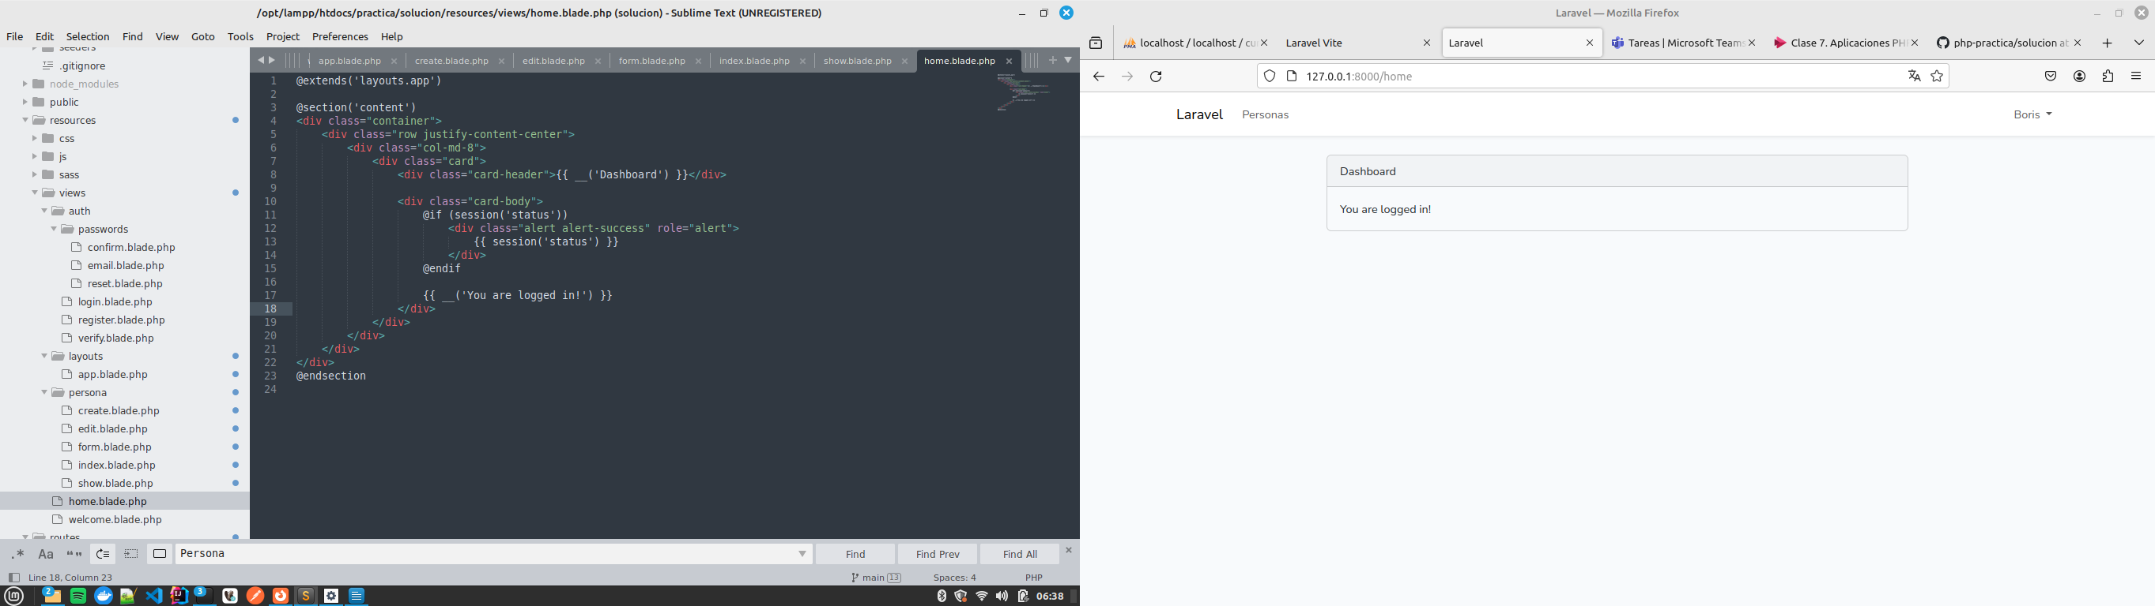

**persona/create.blade.php**

@extends('layouts.app')

@section('template_title')

{{ __('Crear') }} Persona

@endsection

@section('content')

<section class="content container-fluid">

<div class="row">

<div class="col-md-12">

@includeif('partials.errors')

<div class="card card-default">

<div class="card-header">

<span class="card-title">{{ __('Crear') }} Persona</span>

</div>

<div class="card-body">

<form method="POST" action="{{ route('personas.store') }}" role="form" enctype="multipart/form-data">

@csrf

@include('persona.form')

</form>

</div>

</div>

</div>

</div>

</section>

@endsection

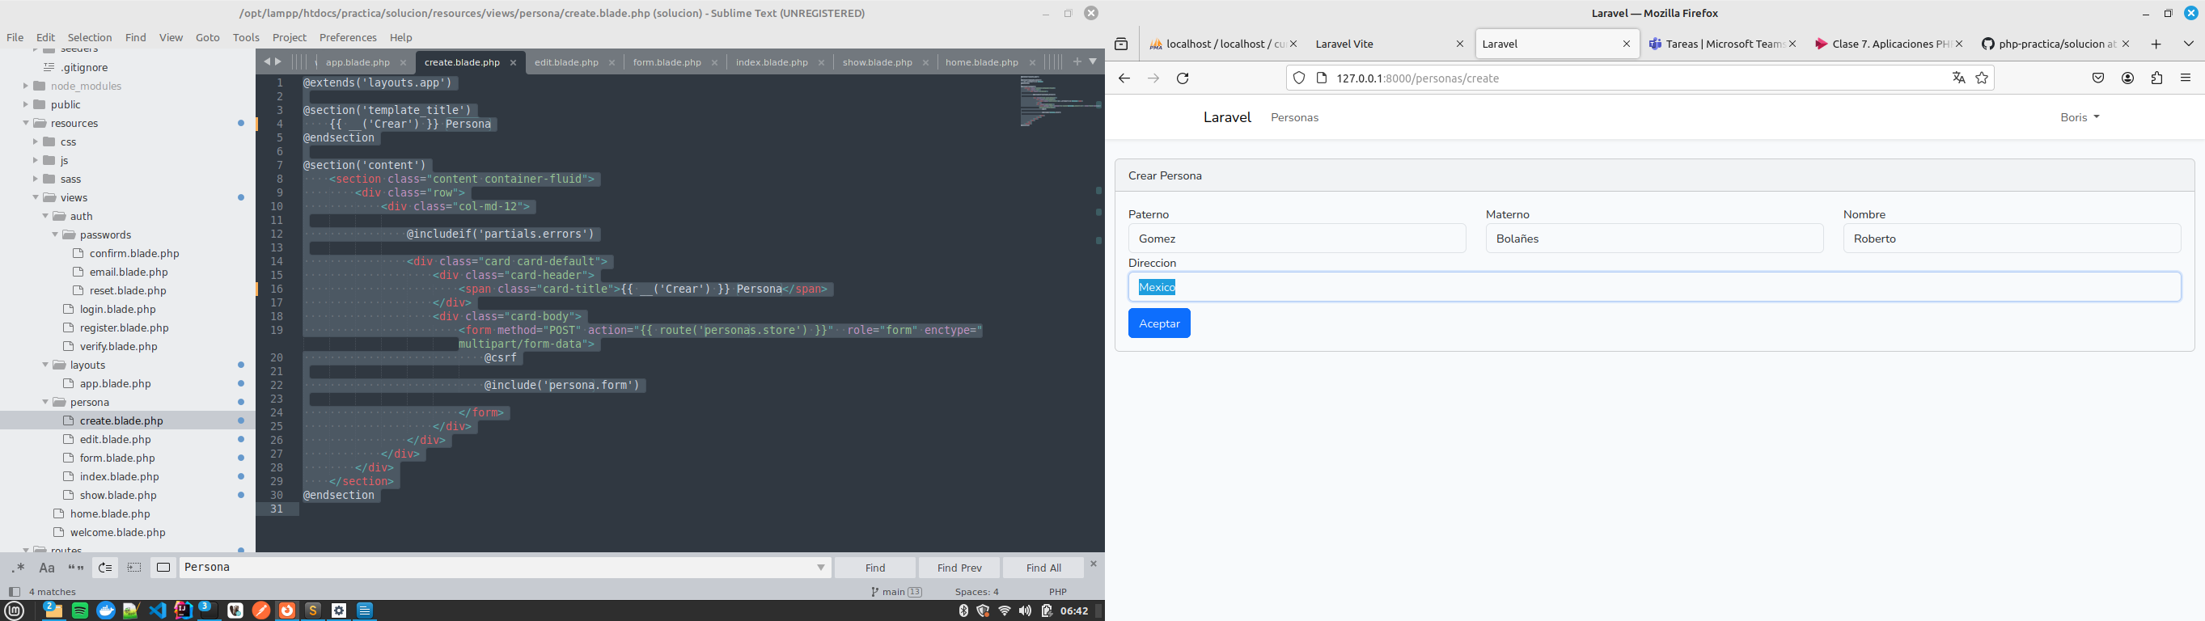

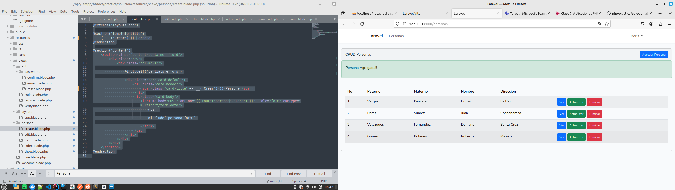

**edit.blade.php**

@extends('layouts.app')

@section('template_title')

{{ __('Actualizar') }} Persona

@endsection

@section('content')

<section class="content container-fluid">

<div class="">

<div class="col-md-12">

@includeif('partials.errors')

<div class="card card-default">

<div class="card-header">

<span class="card-title">{{ __('Actualizar') }} Persona</span>

</div>

<div class="card-body">

<form method="POST" action="{{ route('personas.update', $persona->id) }}" role="form" enctype="multipart/form-data">

{{ method_field('PATCH') }}

@csrf

@include('persona.form')

</form>

</div>

</div>

</div>

</div>

</section>

@endsection

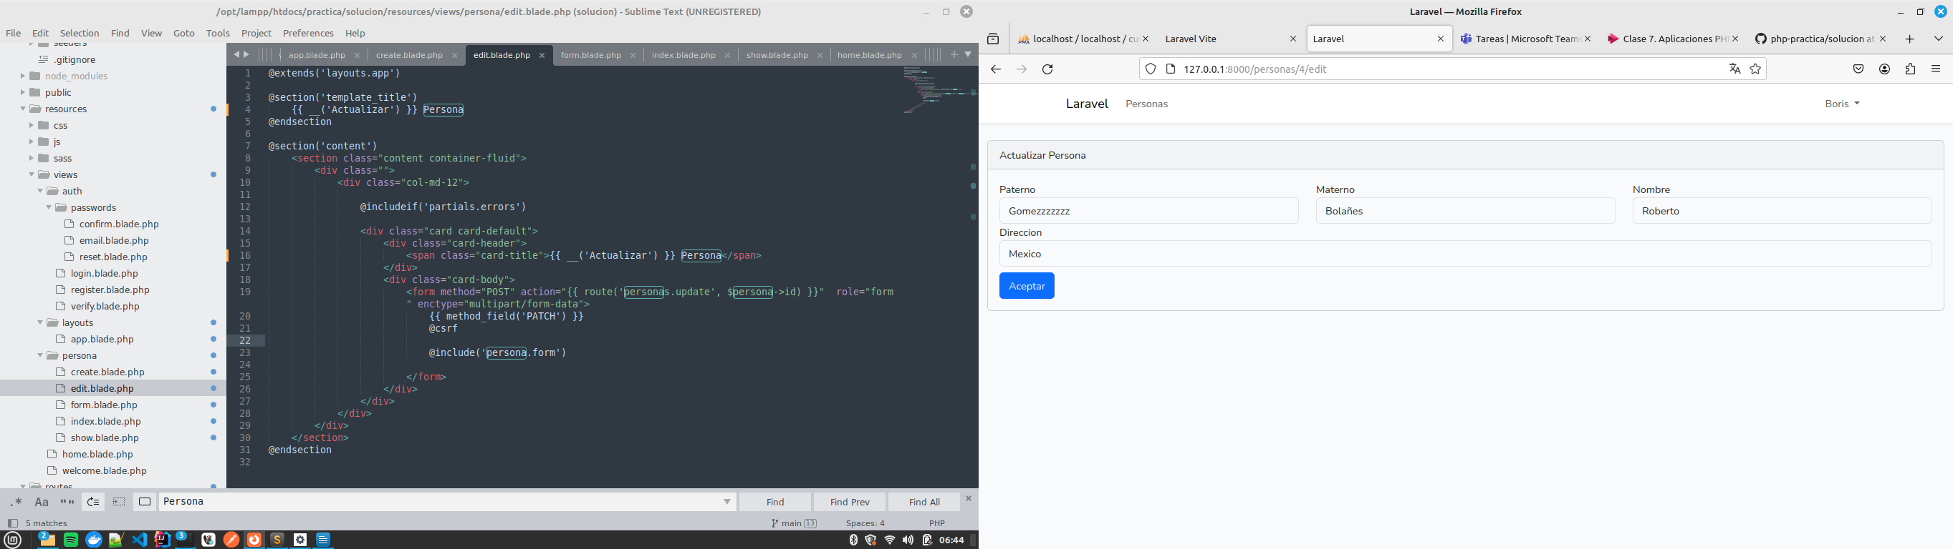

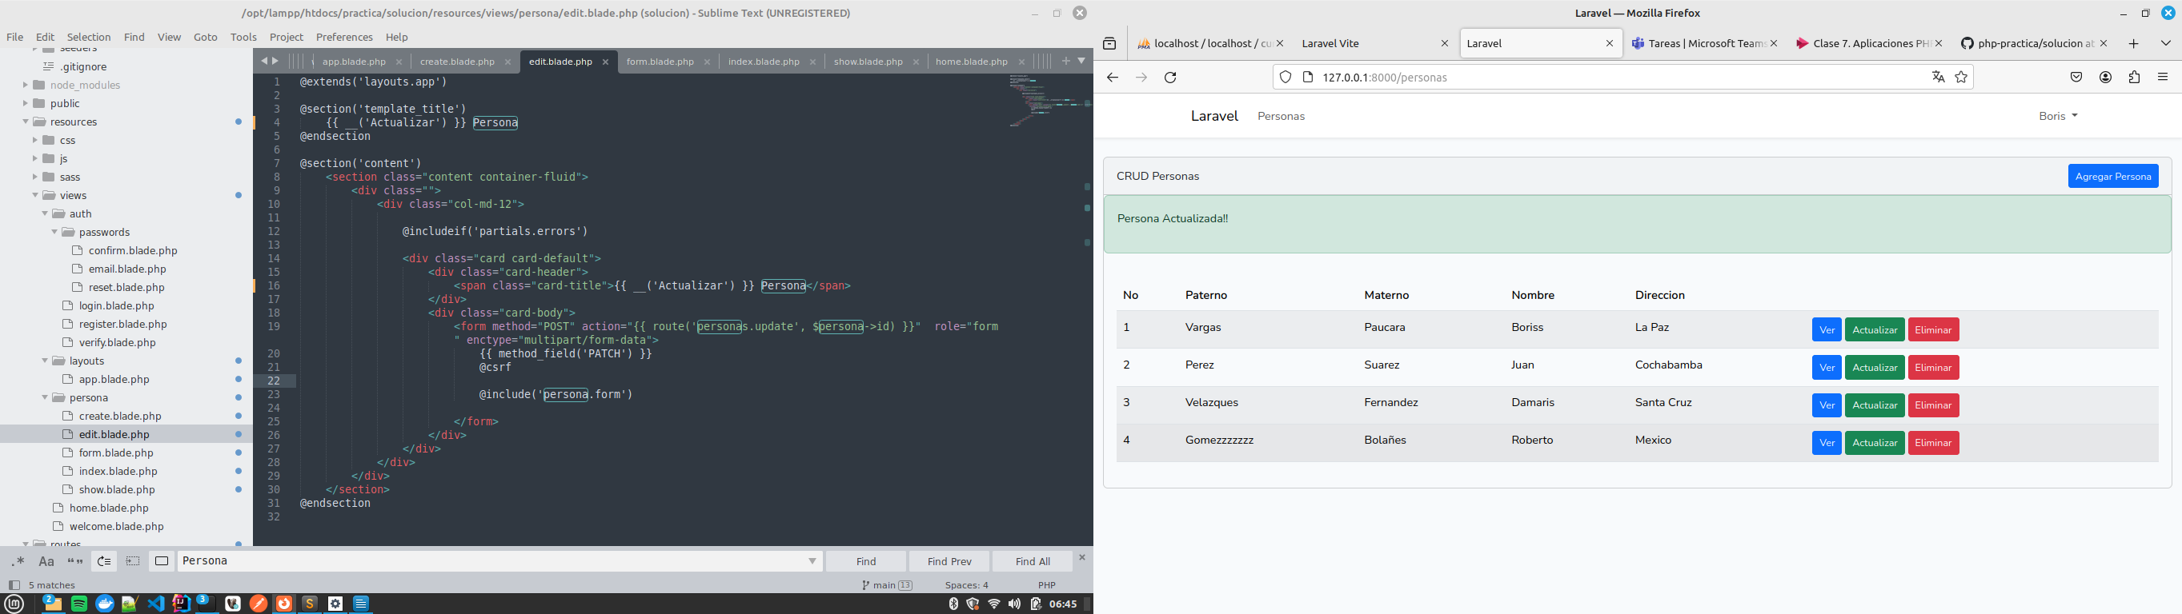

**form.blade.php**

<div class="box box-info padding-1">

<div class="box-body row">

<div class="form-group col-4">

{{ Form::label('paterno') }}

{{ Form::text('paterno', $persona->paterno, ['class' => 'form-control' . ($errors->has('paterno') ? ' is-invalid' : ''), 'placeholder' => 'Paterno']) }}

{!! $errors->first('paterno', '<div class="invalid-feedback">:message</div>') !!}

</div>

<div class="form-group col-4">

{{ Form::label('materno') }}

{{ Form::text('materno', $persona->materno, ['class' => 'form-control' . ($errors->has('materno') ? ' is-invalid' : ''), 'placeholder' => 'Materno']) }}

{!! $errors->first('materno', '<div class="invalid-feedback">:message</div>') !!}

</div>

<div class="form-group col-4">

{{ Form::label('nombre') }}

{{ Form::text('nombre', $persona->nombre, ['class' => 'form-control' . ($errors->has('nombre') ? ' is-invalid' : ''), 'placeholder' => 'Nombre']) }}

{!! $errors->first('nombre', '<div class="invalid-feedback">:message</div>') !!}

</div>

<div class="form-group">

{{ Form::label('direccion') }}

{{ Form::text('direccion', $persona->direccion, ['class' => 'form-control' . ($errors->has('direccion') ? ' is-invalid' : ''), 'placeholder' => 'Direccion']) }}

{!! $errors->first('direccion', '<div class="invalid-feedback">:message</div>') !!}

</div>

</div>

<div class="box-footer mt-2">

<button type="submit" class="btn btn-primary">{{ __('Aceptar') }}</button>

</div>

</div>

**index.blade.php**

@extends('layouts.app')

@section('template_title')

Persona

@endsection

@section('content')

<div class="container-fluid">

<div class="row">

<div class="col-sm-12">

<div class="card">

<div class="card-header">

<div style="display: flex; justify-content: space-between; align-items: center;">

<span id="card_title">

{{ __('CRUD Personas') }}

</span>

<div class="float-right">

<a href="{{ route('personas.create') }}" class="btn btn-primary btn-sm float-right" data-placement="left">

{{ __('Agregar Persona') }}

</a>

</div>

</div>

</div>

@if ($message = Session::get('success'))

<div class="alert alert-success">

<p>{{ $message }}</p>

</div>

@endif

<div class="card-body">

<div class="table-responsive">

<table class="table table-striped table-hover">

<thead class="thead">

<tr>

<th>No</th>

<th>Paterno</th>

<th>Materno</th>

<th>Nombre</th>

<th>Direccion</th>

<th></th>

</tr>

</thead>

<tbody>

@foreach ($personas as $persona)

<tr>

<td>{{ ++$i }}</td>

<td>{{ $persona->paterno }}</td>

<td>{{ $persona->materno }}</td>

<td>{{ $persona->nombre }}</td>

<td>{{ $persona->direccion }}</td>

<td>

<form action="{{ route('personas.destroy',$persona->id) }}" method="POST">

<a class="btn btn-sm btn-primary " href="{{ route('personas.show',$persona->id) }}"><i class="fa fa-fw fa-eye"></i> {{ __('Ver') }}</a>

<a class="btn btn-sm btn-success" href="{{ route('personas.edit',$persona->id) }}"><i class="fa fa-fw fa-edit"></i> {{ __('Actualizar') }}</a>

@csrf

@method('DELETE')

<button type="submit" class="btn btn-danger btn-sm"><i class="fa fa-fw fa-trash"></i> {{ __('Eliminar') }}</button>

</form>

</td>

</tr>

@endforeach

</tbody>

</table>

</div>

</div>

</div>

{!! $personas->links() !!}

</div>

</div>

</div>

@endsection

**show.blade.php**

@extends('layouts.app')

@section('template_title')

{{ $persona->name ?? "{{ __('Ver') Persona" }}

@endsection

@section('content')

<section class="content container-fluid">

<div class="row">

<div class="col-md-12">

<div class="card">

<div class="card-header">

<div class="float-left">

<span class="card-title">{{ __('Ver') }} Persona</span>

</div>

<div class="float-right">

<a class="btn btn-primary" href="{{ route('personas.index') }}"> {{ __('Volver') }}</a>

</div>

</div>

<div class="card-body">

<div class="form-group">

<strong>Paterno:</strong>

{{ $persona->paterno }}

</div>

<div class="form-group">

<strong>Materno:</strong>

{{ $persona->materno }}

</div>

<div class="form-group">

<strong>Nombre:</strong>

{{ $persona->nombre }}

</div>

<div class="form-group">

<strong>Direccion:</strong>

{{ $persona->direccion }}

</div>

</div>

</div>

</div>

</div>

</section>

@endsection

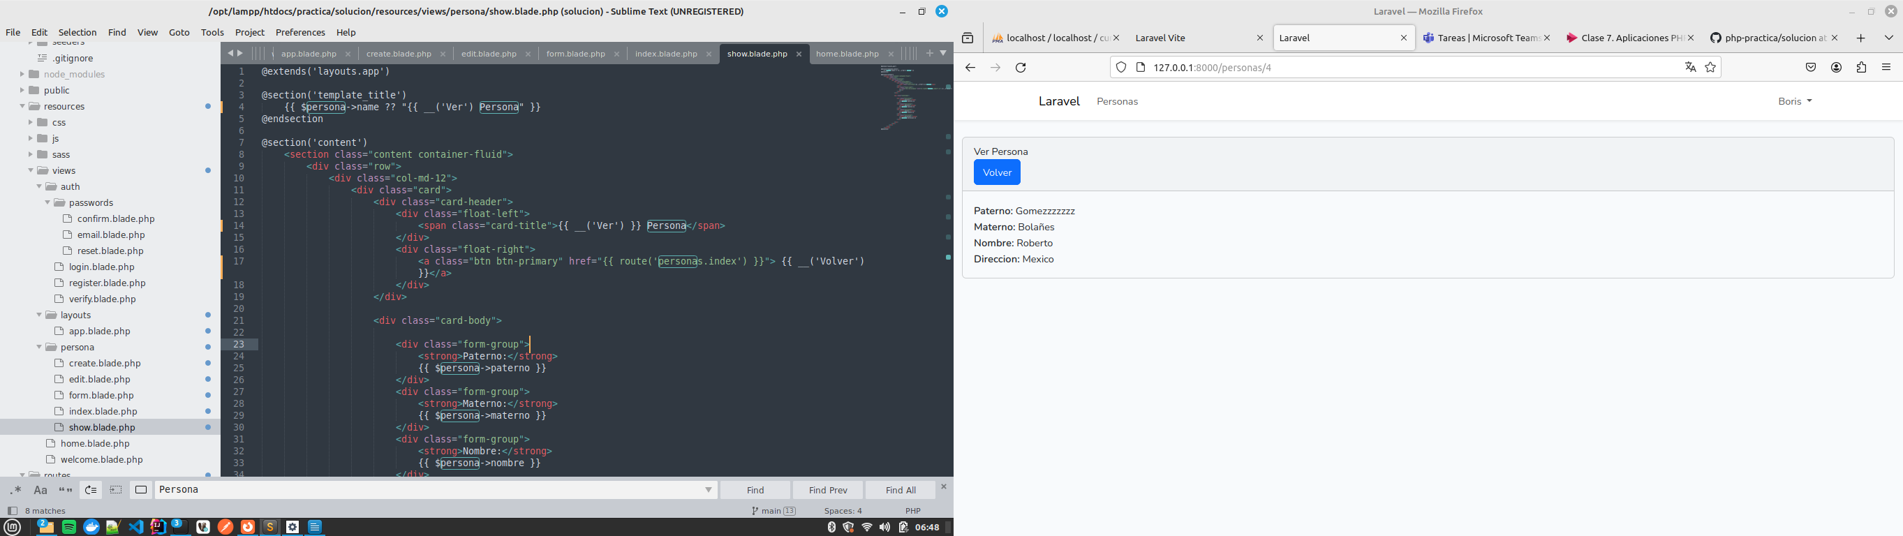

**auth/login.blade.php**

@extends('layouts.app')

@section('content')

<div class="container">

<div class="row justify-content-center">

<div class="col-md-8">

<div class="card">

<div class="card-header">{{ __('Login') }}</div>

<div class="card-body">

<form method="POST" action="{{ route('login') }}">

@csrf

<div class="row mb-3">

<label for="email" class="col-md-4 col-form-label text-md-end">{{ __('Email Address') }}</label>

<div class="col-md-6">

<input id="email" type="email" class="form-control @error('email') is-invalid @enderror" name="email" value="{{ old('email') }}" required autocomplete="email" autofocus>

@error('email')

<span class="invalid-feedback" role="alert">

<strong>{{ $message }}</strong>

</span>

@enderror

</div>

</div>

<div class="row mb-3">

<label for="password" class="col-md-4 col-form-label text-md-end">{{ __('Password') }}</label>

<div class="col-md-6">

<input id="password" type="password" class="form-control @error('password') is-invalid @enderror" name="password" required autocomplete="current-password">

@error('password')

<span class="invalid-feedback" role="alert">

<strong>{{ $message }}</strong>

</span>

@enderror

</div>

</div>

<div class="row mb-3">

<div class="col-md-6 offset-md-4">

<div class="form-check">

<input class="form-check-input" type="checkbox" name="remember" id="remember" {{ old('remember') ? 'checked' : '' }}>

<label class="form-check-label" for="remember">

{{ __('Remember Me') }}

</label>

</div>

</div>

</div>

<div class="row mb-0">

<div class="col-md-8 offset-md-4">

<button type="submit" class="btn btn-primary">

{{ __('Login') }}

</button>

@if (Route::has('password.request'))

<a class="btn btn-link" href="{{ route('password.request') }}">

{{ __('Forgot Your Password?') }}

</a>

@endif

</div>

</div>

</form>

</div>

</div>

</div>

</div>

</div>

@endsection

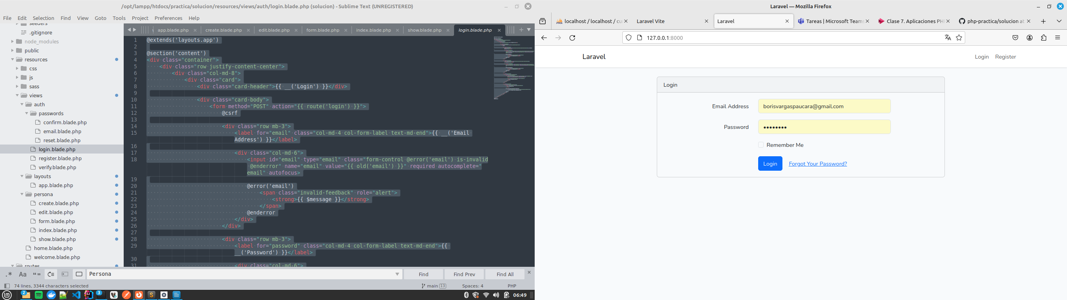

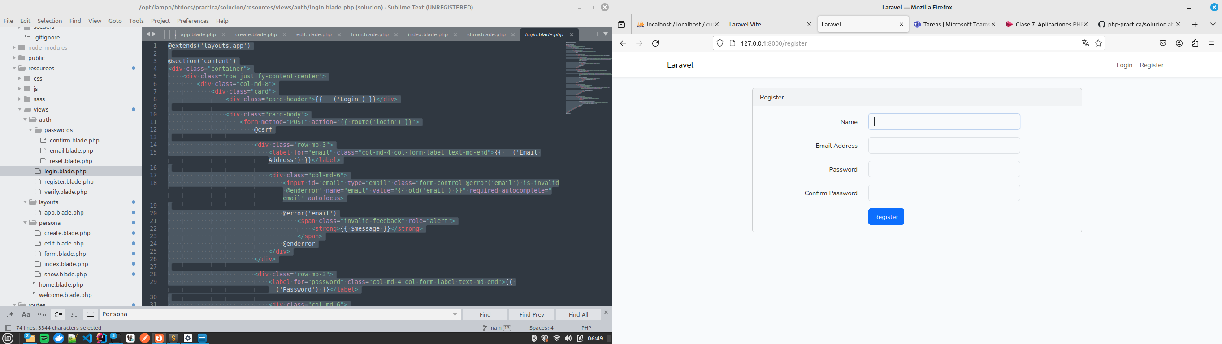

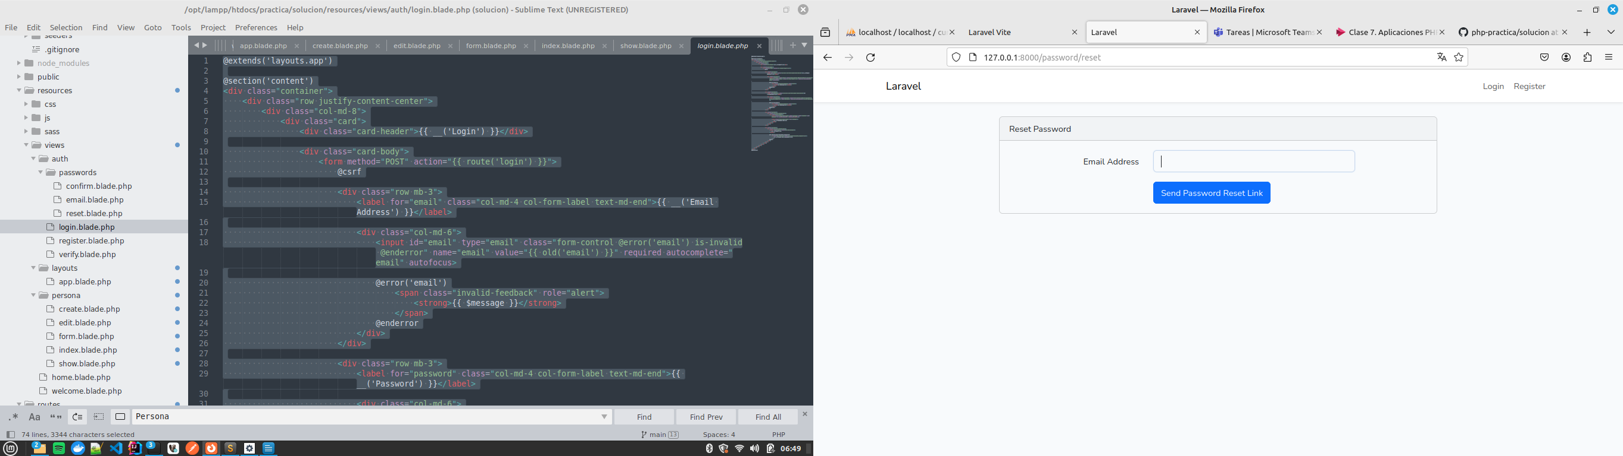

**ROUTES**

**web.php**

<?php

use Illuminate\Support\Facades\Route;

Route::get('/', function () {

return view('auth.login');

});

Auth::routes();

Route::resource('personas', App\Http\Controllers\PersonaController::class)->middleware('auth');

Route::get('/home', [App\Http\Controllers\HomeController::class, 'index'])→name('home');

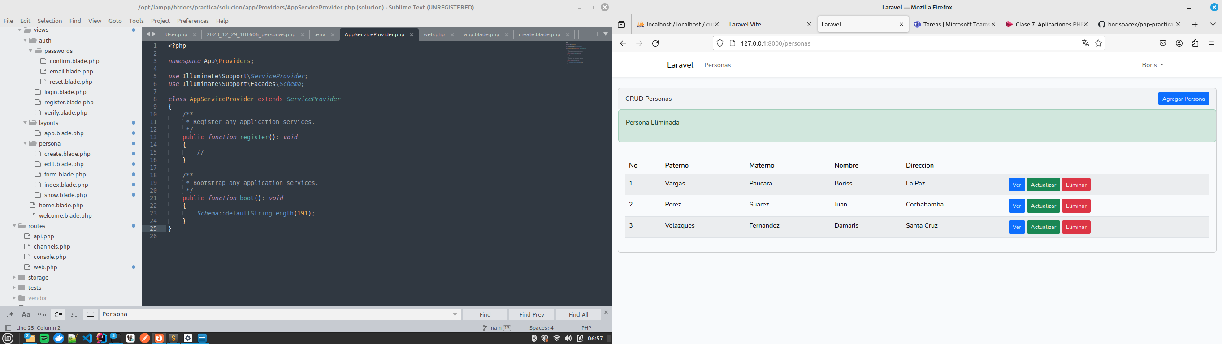

**BASE DE DATOS**

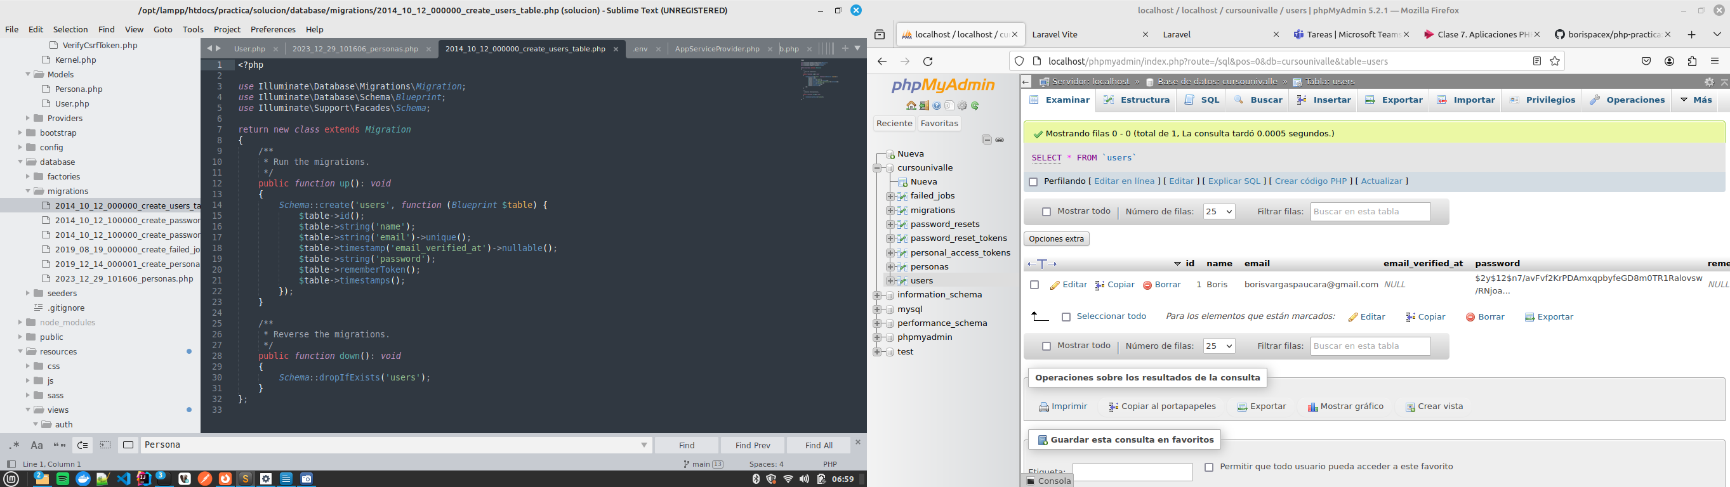

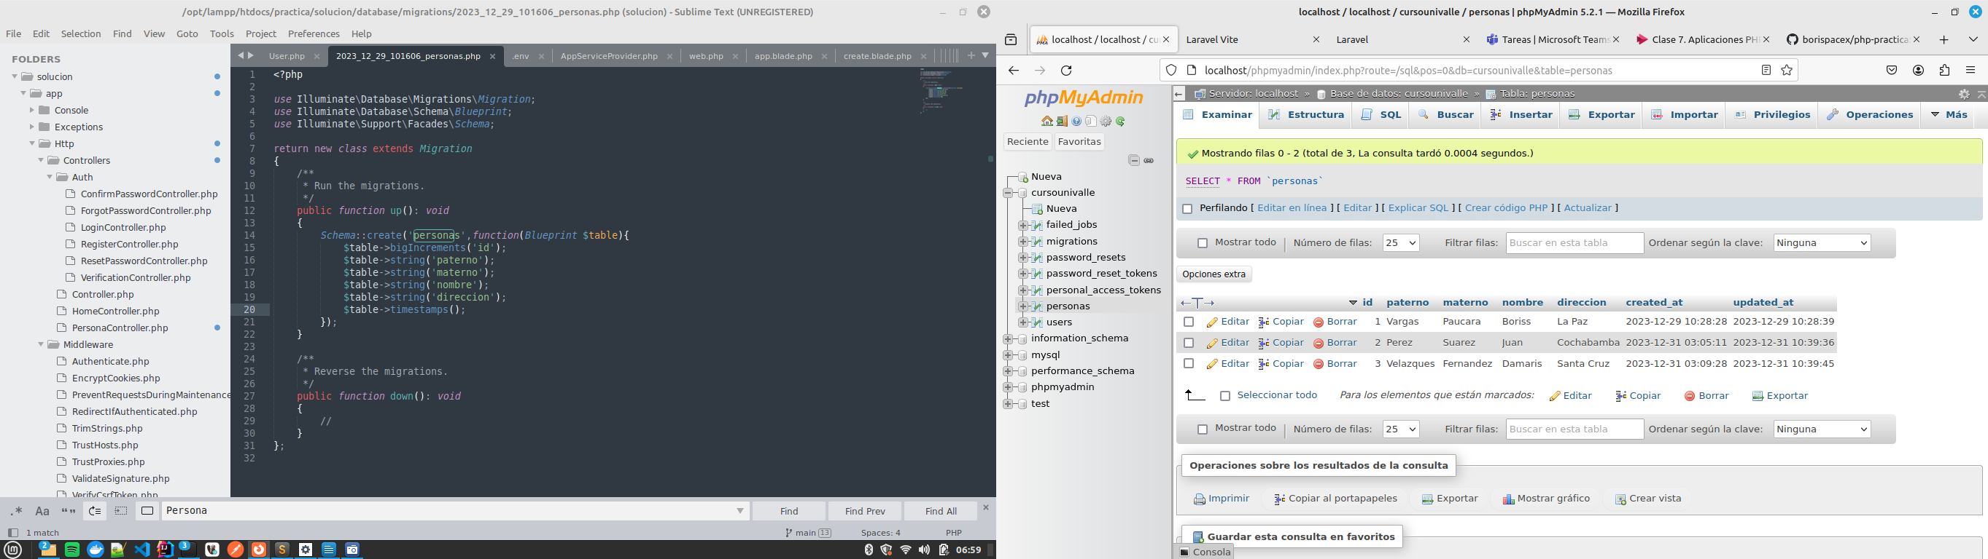

**PARA MAS DETALLES SE PUEDE VER EN EL REPOSITORIO:**

https://github.com/borispacex/php-practica

